Create database
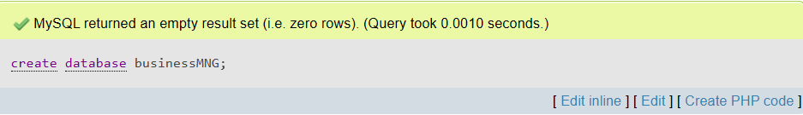
Consider the following
- Businesses ( PAN, business_name, registered_date)
- Business_address (PAN, address_type, district, VDC_MUN, tole)
- Transactions (PAN, tranno, fiscal_year, amount)

Create table Businesses
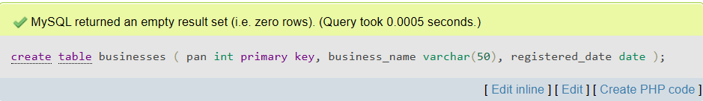
Create table Business_address
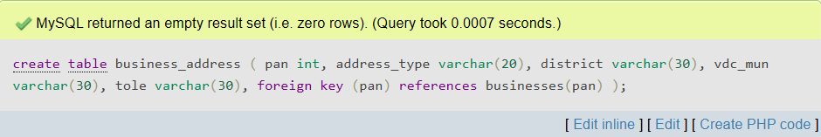
Create table Transactions
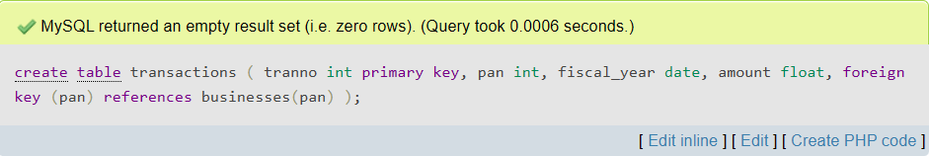

Describe Businesses
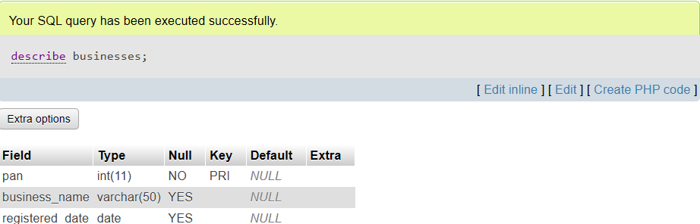
Insert Businesses
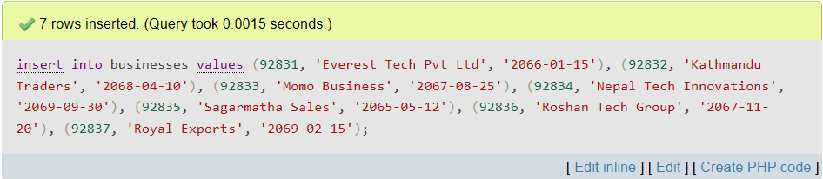
Display Businesses
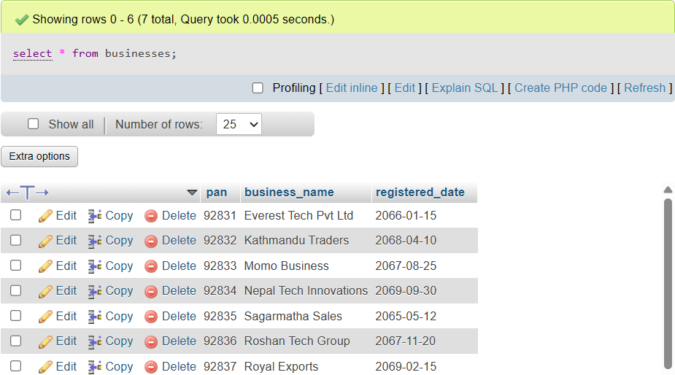

Describe Business_address
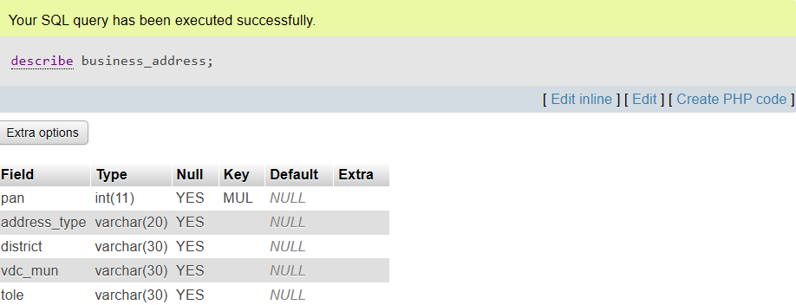
Insert Business_address
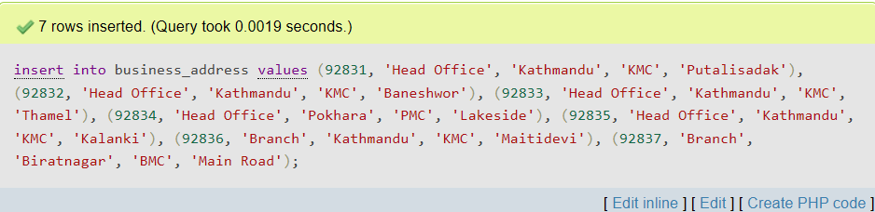
Display Business_address
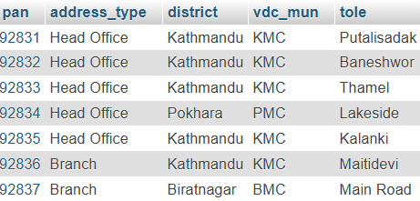
Describe Transactions
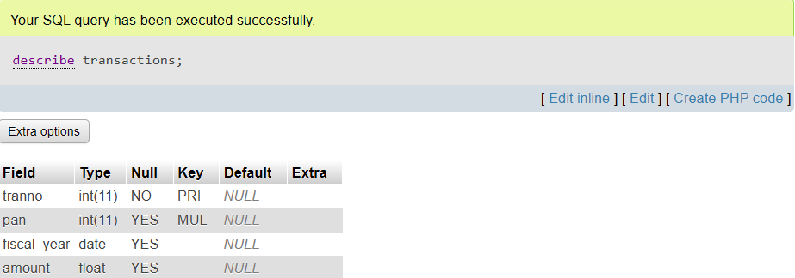
Insert Transactions
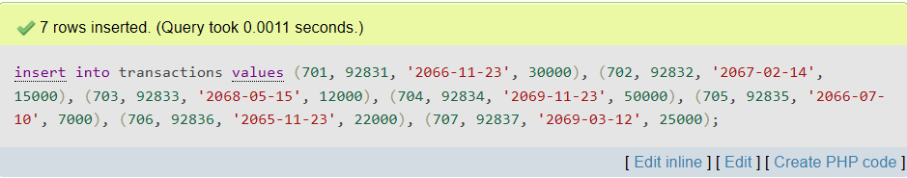
Display Transactions
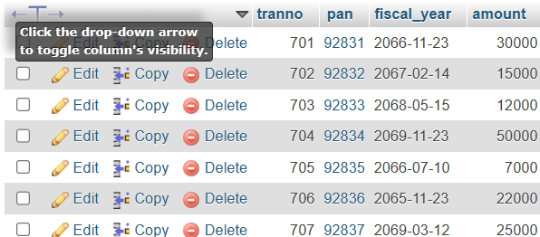

- Write SQL queries
- Find PAN and business name of businesses that has word “tech” somewhere.
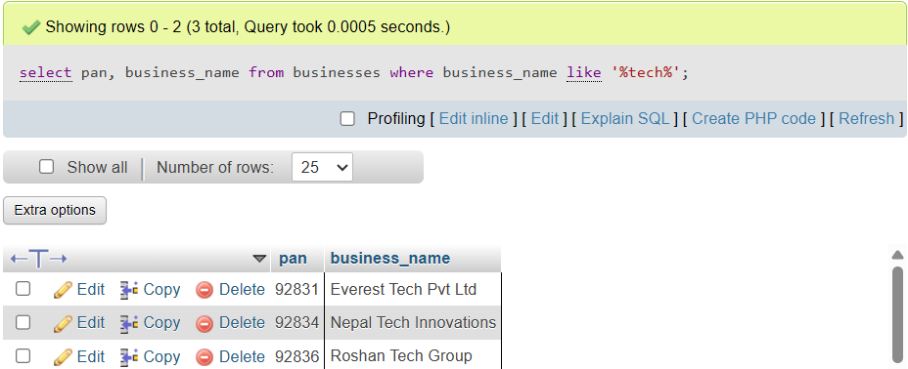
- Retrieve pan, business name, registration date of the companies that is registered between “2065-03-11” and “2070-05-25” in Kathmandu.
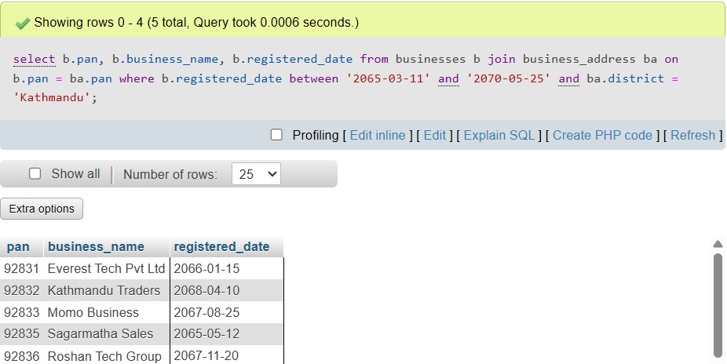

3. Fins pan, business name and total amount of the business for the fiscal year
“2065-11-23”.
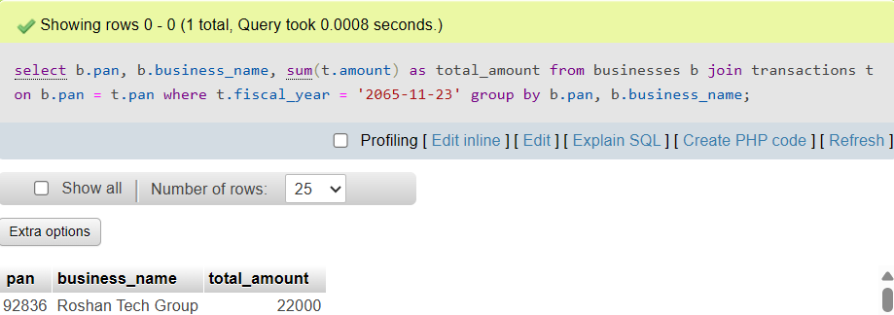
- Display the sum of all transactions.
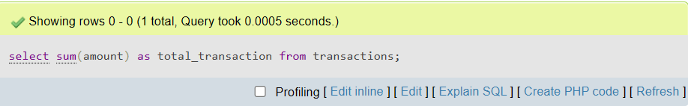

- Change the name of business “momo business “which pan is 92835.
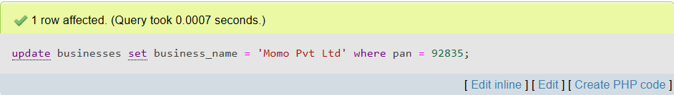
6. Add the new attribute for businesses
